**RAILWAY MANAGEMENT SYSTEM**

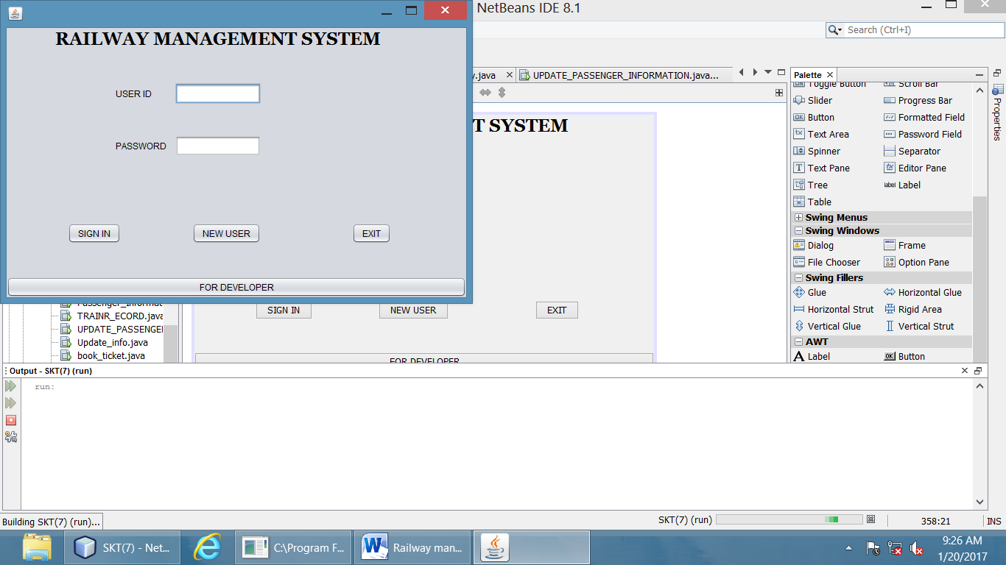.

**CODE FOR IMPORTING THE PACKAGES:**

import java.sql.Connection;

import java.sql.DriverManager;

import java.sql.ResultSet;

import java.sql.Statement;

**CODE FOR SIGN IN BUTTON :**

private void jButton1ActionPerformed(java.awt.event.ActionEvent evt) {

String user= tf1.getText();

String pw="" , un="";

String p= tf2.getText();

try

{

Class.forName("java.sql.Driver");

System.out.println("correct");

Connection co = DriverManager.getConnection("jdbc:mysql://localhost/skt7","root","lps");

System.out.println("correct");

Statement st = co.createStatement();

System.out.println("correct");

String signu = "select * from signup where uname = '"+user+"';";

System.out.println("correct");

ResultSet rs = st.executeQuery(signu);

System.out.println("correct");

if(rs.next())

{

un= rs.getString(8);

pw=rs.getString(7);

if(p.equals(pw) && user.equalsIgnoreCase(un))

{

new HOUSE().setVisible(true);

this.setVisible(false);

}

else

{op1.showMessageDialog(null,"invalid input");

}

}

}

catch(Exception e)

{

System.out.println("ERROR");

}

**CODE FOR NEW USER BUTTON :**

private void jButton3ActionPerformed(java.awt.event.ActionEvent evt) {

new signup().setVisible(true);

this.setVisible(false);

**CODE FOR DEVELOPER BUTTON:**

private void jButton4ActionPerformed(java.awt.event.ActionEvent evt) {

new prog_login().setVisible(true);

this.setVisible(false);

**CODE FOR EXIT BUTTON :**

private void jButton2ActionPerformed(java.awt.event.ActionEvent evt) {

System.exit(0);

**AFTER CLICKING ON NEW USER BUTTON FOLLOWING WINDOW WILL BE DISPLAYED :**

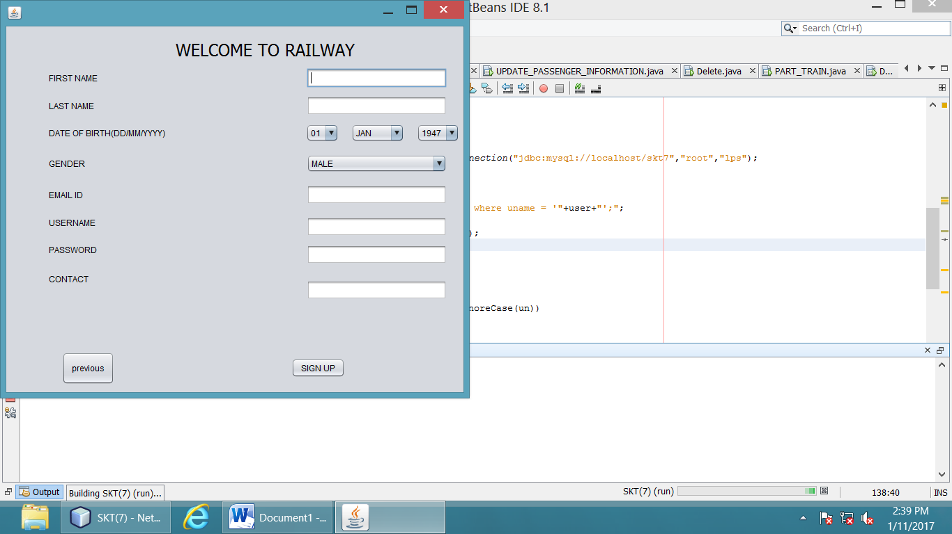

**CODE FOR SIGNUP BUTTON :**

private void jButton1ActionPerformed(java.awt.event.ActionEvent evt) {

String dat = (String)date.getSelectedItem();

String month = (String)mon.getSelectedItem();

String yea = (String)year.getSelectedItem();

String gen = (String)cb1.getSelectedItem();

String d ="";

if(month.equals("JAN"))

d="01";

else

if(month.equals("FEB"))

d="02";

else

if(month.equals("MARCH"))

d="03";

else

if(month.equals("APRIL"))

d="04";

else

if(month.equals("MAY"))

d="05";

else

if(month.equals("JUNE"))

d="06";

else

if(month.equals("JULY"))

d="07";

else

if(month.equals("AUG"))

d="08";

else

if(month.equals("SEPT"))

d="09";

else

if(month.equals("OCT"))

d="10";

else

if(month.equals("NOV"))

d="11";

else

if(month.equals("DEC"))

d="12";

String dob = yea+"-"+d+"-"+dat;

String fname = tf1.getText();

String lname = tf2.getText();

String email = tf5.getText();

String user = tf6.getText();

String passw = tf7.getText();

String contact = tf8.getText();

try

{

Class.forName("java.sql.Driver");

System.out.println("correct");

Connection co = DriverManager.getConnection("jdbc:mysql://localhost/skt7","root","lps");

System.out.println("correct");

Statement st = co.createStatement();

System.out.println("correct");

String sq = "insert into signup (fname,lname,dob,gender,email,contact,password,uname)values('"+fname+"','"+lname+"','"+dob+"','"+gen+"','"+email+"','"+contact+"','"+passw+"','"+user+"');";

System.out.println("correct");

st.executeUpdate(sq);

new HOUSE().setVisible(true);

this.setVisible(false);}

catch(Exception e)

{

System.out.println("nootcorrect"); }

**CODE FOR PREVIOUS BUTTON :**

private void jButton2ActionPerformed(java.awt.event.ActionEvent evt) {

new login().setVisible(true);

this.setVisible(false);

**AFTER CLICKING ON PREVIOUS BUTTON LOGIN WINDOW WILL BE DISPLAYED:**

**AFTER CLICKING ON SIGNUP BUTTON FOLLOWING WINDOW WILL BE DISPLAYED:**

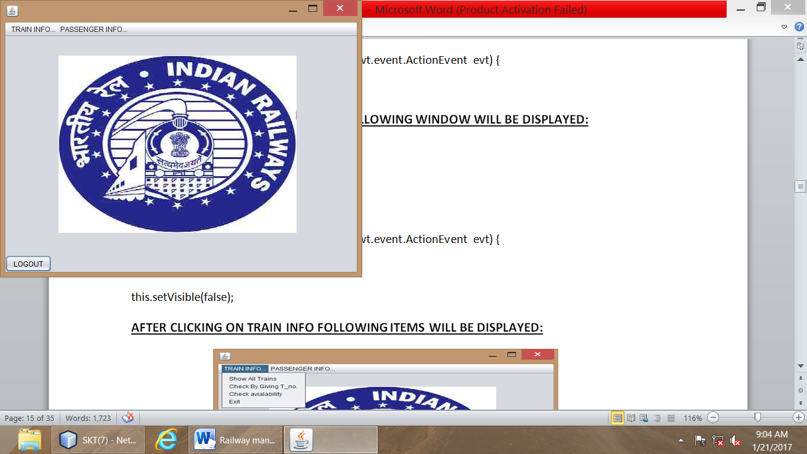

**AFTER CLICKING ON FOR DEVELOPER BUTTON FOLLOWING WINDOW WILL BE DISPLAYED:**

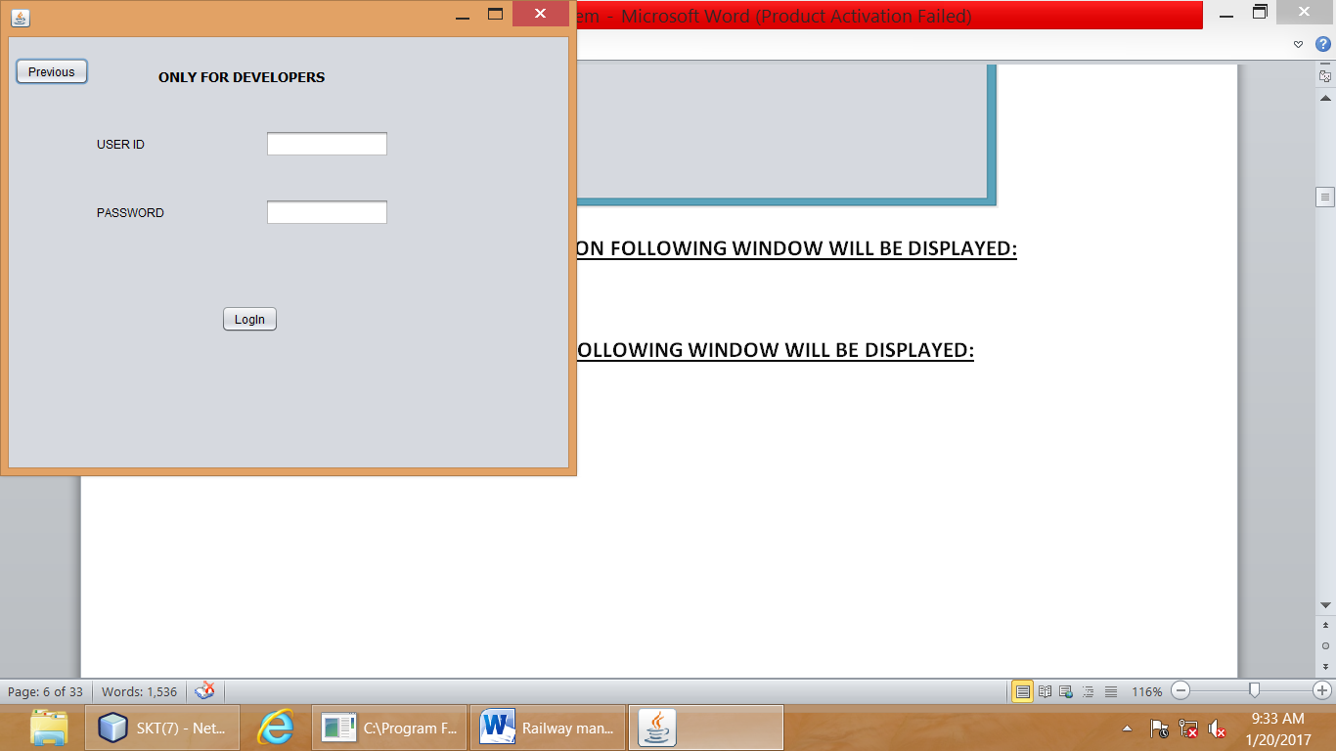

**CODE FOR PREVIOUS BUTTON:**

private void jButton2ActionPerformed(java.awt.event.ActionEvent evt) {

new login().setVisible(true);

this.setVisible(false);

**AFTER CLICKING ON PREVIOUS BUTTON WE WILL JUMP ON LOGIN WINDOW:**

**CODE FOR LOGIN BUTTON:**

private void jButton1ActionPerformed(java.awt.event.ActionEvent evt) {

String u = tf1.getText();

String pa = tf2.getText();

if("123skt".equals(pa) & "shailjakant".equals(u))

{

new Update_info().setVisible(true);

this.setVisible(false);

}

else

{

op1.showMessageDialog(null,"invalid input");

}

**AFTER CLICKING ON LOGIN BUTTON FOLLOWING WINDOW WILL BE DISPLAYED:**

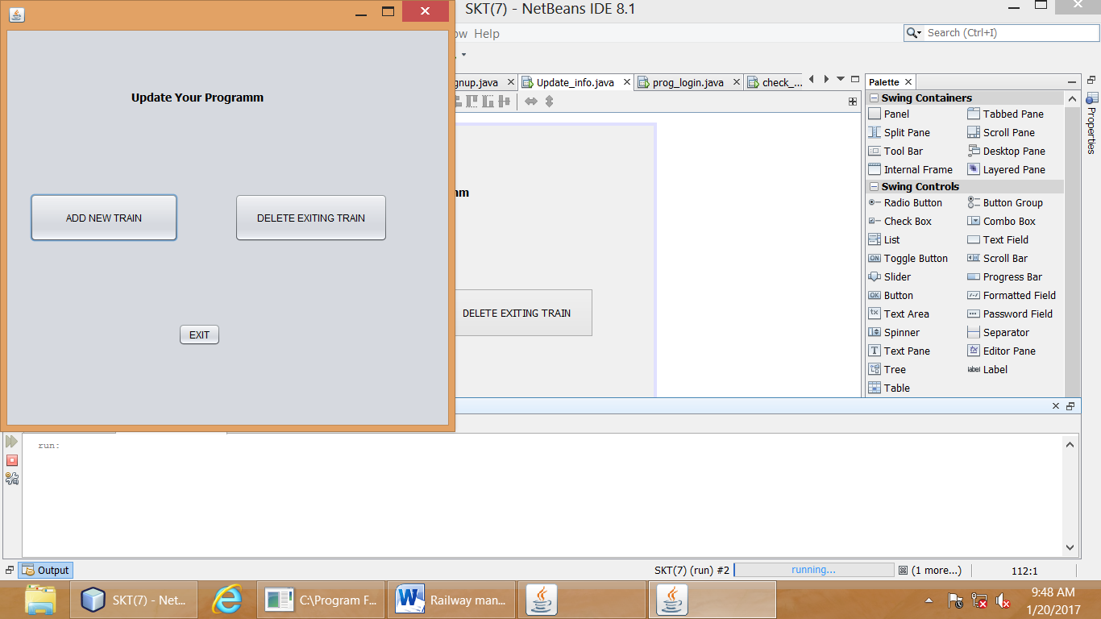

**CODE FOR ADD NEW TRAIN BUTTON:**

private void jButton1ActionPerformed(java.awt.event.ActionEvent evt) {

new train_entry().setVisible(true);

this.setVisible(false);

**CODE FOR DELETE EXITING TRAIN BUTTON:**

private void jButton2ActionPerformed(java.awt.event.ActionEvent evt) {

new Delete_train().setVisible(true);

this.setVisible(false);

**CODE FOR EXIT BUTTON:**

private void jButton4ActionPerformed(java.awt.event.ActionEvent evt) {

System.exit(0);

**AFTER CLICKING ON ADD NEW TRAIN FOLLOWING WINDOW WILL BE DISPLAYED:**

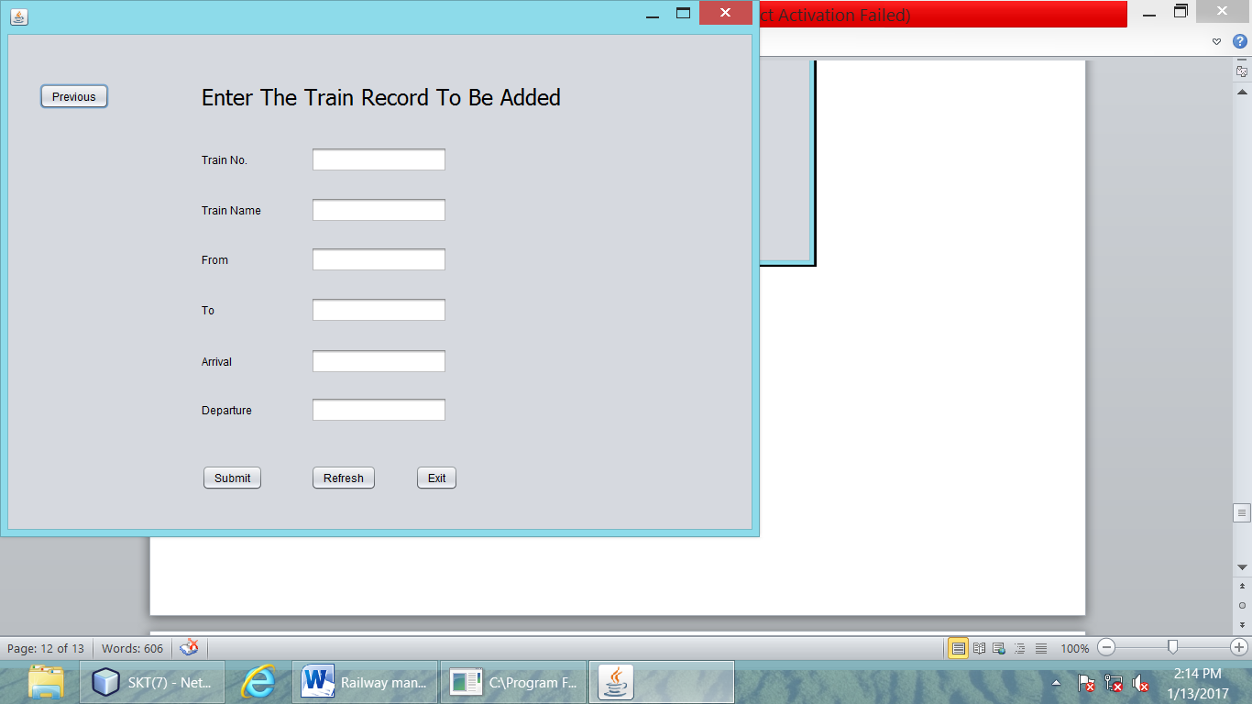

**CODE FOR SUBMIT BUTTON:**

private void jButton4ActionPerformed(java.awt.event.ActionEvent evt) {

int no= Integer.parseInt(n.getText());

String na= nam.getText();

String frm= fr.getText();

String ta= t.getText();

String a= ar.getText();

String d= de.getText();

try

{

Class.forName("java.sql.Driver");

System.out.println("correct");

Connection co = DriverManager.getConnection("jdbc:mysql://localhost/skt7","root","lps");

System.out.println("correct");

Statement st = co.createStatement();

System.out.println("correct");

String ins = "insert into train (t_no,t_name,frm,too,arrival,departure)values("+no+",'"+na+"','"+frm+"','"+ta+"','"+a+"','"+d+"') ;";

System.out.println("correct");

st.executeUpdate(ins);

System.out.println("correct");

op1.showMessageDialog(null,"Records successfully added");

}

catch(Exception e)

{

System.out.println("error");

}

**CODE FOR REFRESH BUTTON:**

private void jButton2ActionPerformed(java.awt.event.ActionEvent evt) {

n.setText("");

nam.setText("");

fr.setText("");

t.setText("");

ar.setText("");

de.setText("");

**CODE FOR PREVIOUS BUTTON:**

private void jButton1ActionPerformed(java.awt.event.ActionEvent evt) {

new POP_UP_MENU().setVisible(true);

this.setVisible(false);

**AFTER CLICKING ON PREVIOUS BUTTON WE WILL JUMP ON UPDATE YOUR PROGRAMM WINDOW :**

**CODE FOR EXIT BUTTON:**

private void jButton3ActionPerformed(java.awt.event.ActionEvent evt) {

System.exit(0);

**AFTER CLICKING ON DELETE EXITING TRAIN FOLLOWING WINDOW WILL BE DISPLAYED:**

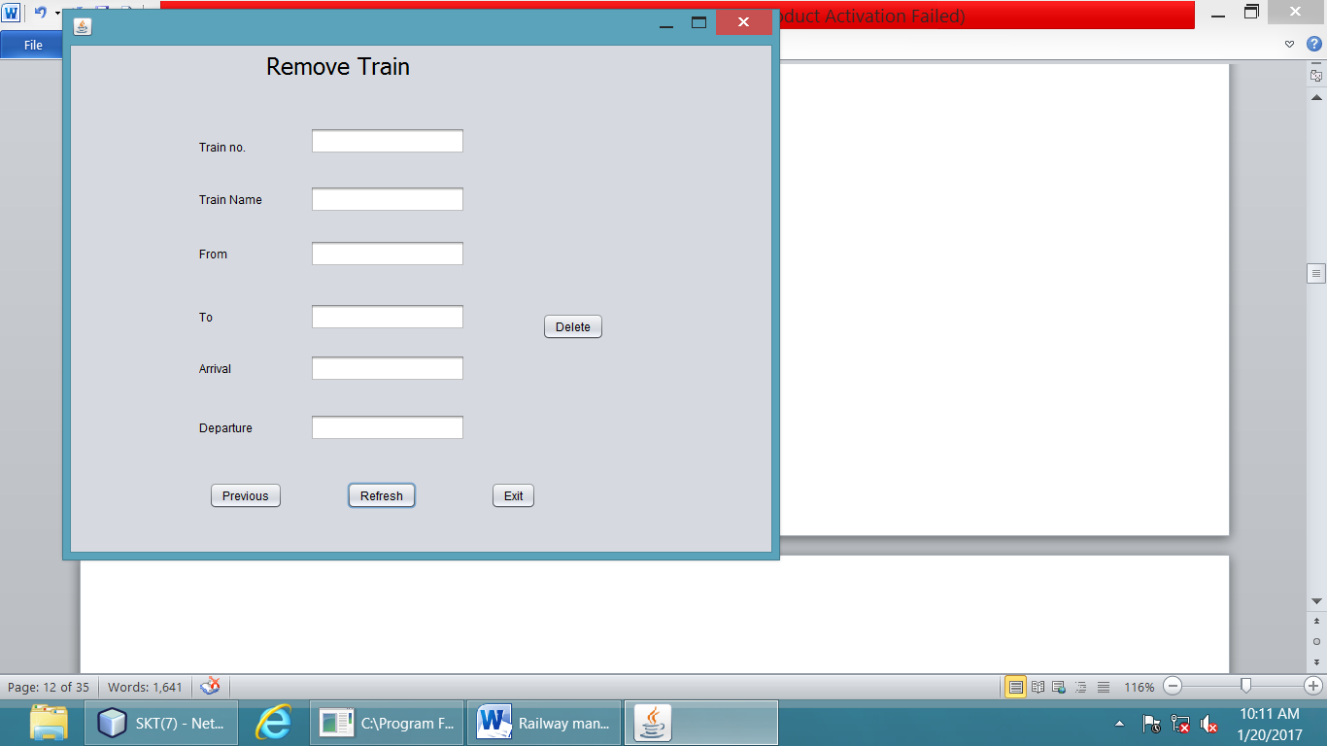

**CODE AT FOCUS LOST OF TEXT FIELD1:**

private void tf1FocusLost(java.awt.event.FocusEvent evt) {

int tn=Integer.parseInt(tf1.getText());

String nam,frm,too,dp,ar;

try{

Class.forName("java.sql.Driver");

System.out.println("correct");

Connection co = DriverManager.getConnection("jdbc:mysql://localhost/skt7","root","lps");

System.out.println("correct");

Statement st = co.createStatement();

System.out.println("correct");

String ser = "select * from train where t_no = "+tn+";";

System.out.println("correct");

ResultSet rs = st.executeQuery(ser);

System.out.println("correct");

if(rs.next())

{

nam = rs.getString(2);

ar = rs.getString(5);

dp = rs.getString(6);

frm = rs.getString(3);

too = rs.getString(4);

tf2.setText(nam);

tf3.setText(frm);

tf4.setText(too);

tf5.setText(ar);

tf6.setText(dp);

}}

catch(Exception e)

{System.out.println("ERROR")}

**AS THE FOCUS IS LOST OF TEXTFIELD1 THE WHOLE DATA WILL BE DISPLAYED AS FOLLOWS:**

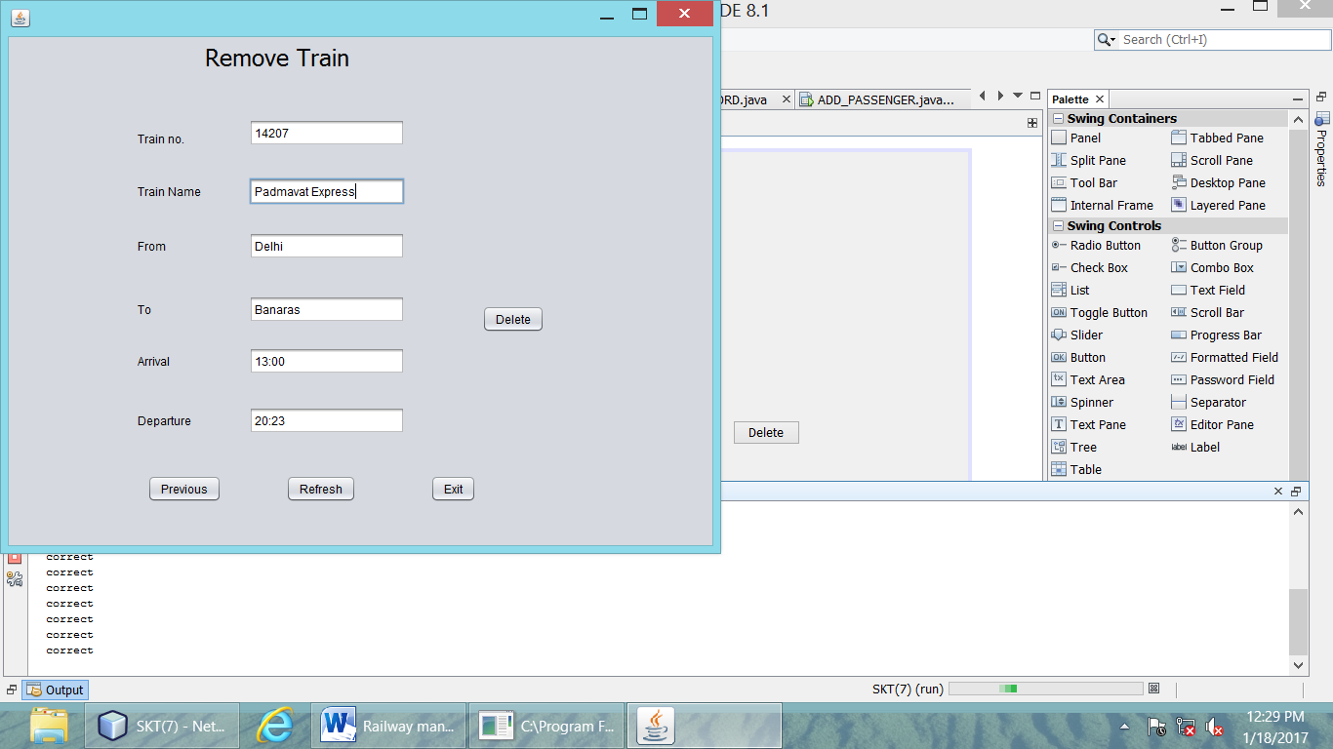

**CODE FOR DELETE BUTTON:**

private void jButton5ActionPerformed(java.awt.event.ActionEvent evt) {

int tn=Integer.parseInt(tf1.getText());

try

{

Class.forName("java.sql.Driver");

System.out.println("correct");

Connection co = DriverManager.getConnection("jdbc:mysql://localhost/skt7","root","lps");

System.out.println("correct");

Statement st = co.createStatement();

System.out.println("correct");

String del = "delete from train where t_no = "+tn+";";

System.out.println("correct");

st.executeUpdate(del);

System.out.println("correct");

op1.showMessageDialog(null,"Records deleted Successfully");

}

catch(Exception e)

{

System.out.println("ERROR");

}

**OUTPUT FOR DELETE COMMAND:**

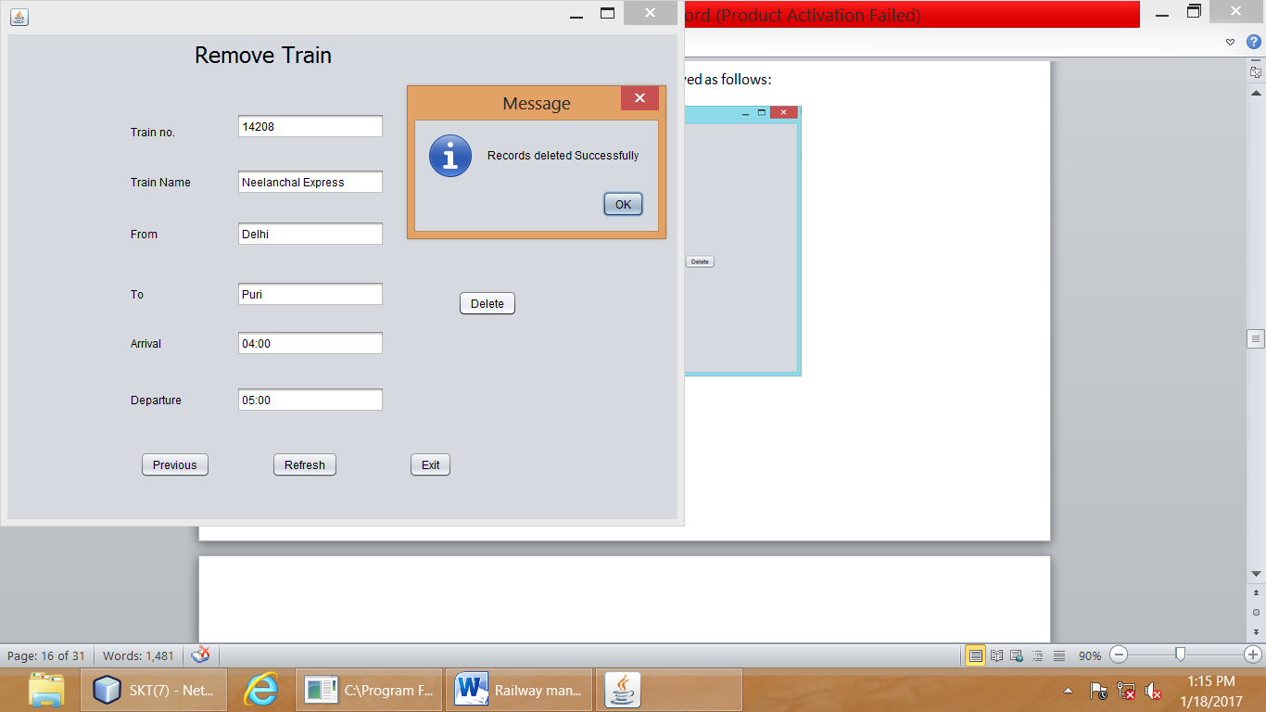

**CODE FOR REFRESH BUTTON:**

private void jButton2ActionPerformed(java.awt.event.ActionEvent evt) {

tf1.setText("");

tf2.setText("");

tf3.setText("");

tf4.setText("");

tf5.setText("");

tf6.setText("");

**CODE FOR PREVIOUS BUTTON:**

private void jButton4ActionPerformed(java.awt.event.ActionEvent evt) {

new POP_UP_MENU().setVisible(true);

this.setVisible(false);

**AFTER CLICKING ON PREVIOUS BUTTON WE WILL JUMP ON THE UPDATE YOUR PROGRAMM WINDOW:**

**CODE FOR EXIT BUTTON:**

private void jButton3ActionPerformed(java.awt.event.ActionEvent evt) {

System.exit(0);

**AFTER CLICKING ON SIGNIN BUTTON FOLLOWING WINDOW WILL BE DISPLAYED:**



**CODE FOR LOGOUT BUTTON:**

private void jButton1ActionPerformed(java.awt.event.ActionEvent evt) {

new login().setVisible(true);

this.setVisible(false);

**AFTER CLICKING ON TRAIN INFO FOLLOWING ITEMS WILL BE DISPLAYED:**

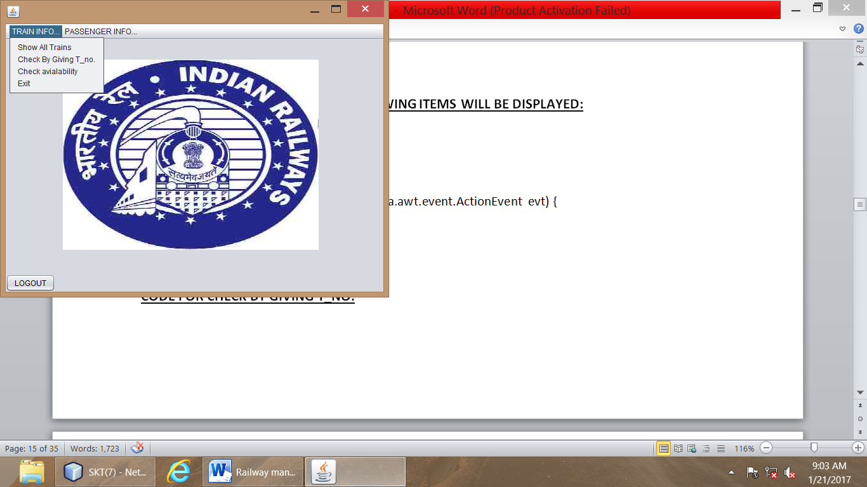

**CODE FOR SHOW ALL TRAINS:**

private void jMenuItem4ActionPerformed(java.awt.event.ActionEvent evt) {

new TRAINR_ECORD().setVisible(true);

this.setVisible(false);

**CODE FOR CHECK BY GIVING T_NO.**

private void jMenuItem3ActionPerformed(java.awt.event.ActionEvent evt) {

new PART_TRAIN().setVisible(true);

this.setVisible(false);

**CODE FOR CHECK AVIALABILITY:**

private void jMenuItem1ActionPerformed(java.awt.event.ActionEvent evt) {

new check_trains().setVisible(true);

this.setVisible(false);

**CODE FOR EXIT:**

private void jMenuItem2ActionPerformed(java.awt.event.ActionEvent evt) {

System.exit(0);

**AFTER CLICKING ON SHOW ALL TRAINS FOLLOWING WINDOWS WILL BE DISPLAYED:**

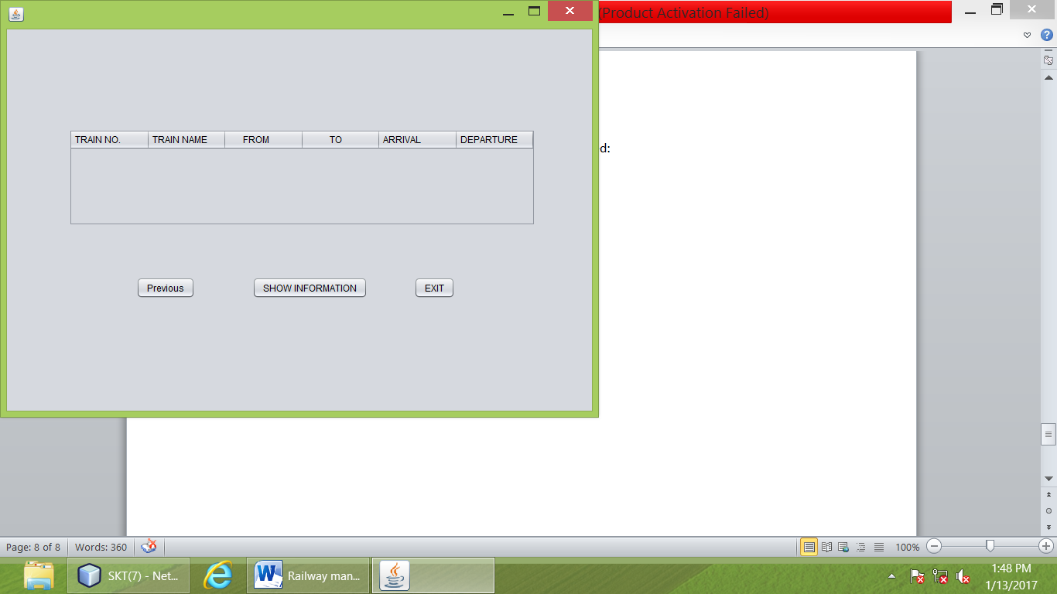

**CODE FOR SHOW INFORMATION:**

private void SHOW_INFORMATIONActionPerformed(java.awt.event.ActionEvent evt) {

DefaultTableModel j = (DefaultTableModel)jTable1.getModel();

int tno;

String tn,f,t,a,d;

try

{

Class.forName("java.sql.Driver");

System.out.println("correct");

Connection co = DriverManager.getConnection("jdbc:mysql://localhost/skt7","root","lps");

System.out.println("correct");

Statement st = co.createStatement();

System.out.println("correct");

String pinf = "select * from train ;";

System.out.println("correct");

ResultSet rs = st.executeQuery(pinf);

System.out.println("correct");

while(rs.next())

{

tno = rs.getInt(1);

tn = rs.getString(2);

f = rs.getString(3);

t = rs.getString(4);

a = rs.getString(5);

d = rs.getString(6);

j.addRow(new Object[]{tno,tn,f,t,a,d});

}

}

catch(Exception e)

{

System.out.println("ERROR");

}

**CODE FOR PREVIOUS BUTTON:**

private void jButton1ActionPerformed(java.awt.event.ActionEvent evt) {

new POP_UP_MENU().setVisible(true);

this.setVisible(false);

**AFTER CLICKING ON PREVIOUS BUTTON POP UP MENU WINDOW WILL BE DISPLAYED:**

**CODE FOR EXIT BUTTON:**

private void jButton2ActionPerformed(java.awt.event.ActionEvent evt) { System.exit(0);

**OUTPUT FOR SHOW INFORMATION COMMAND:**

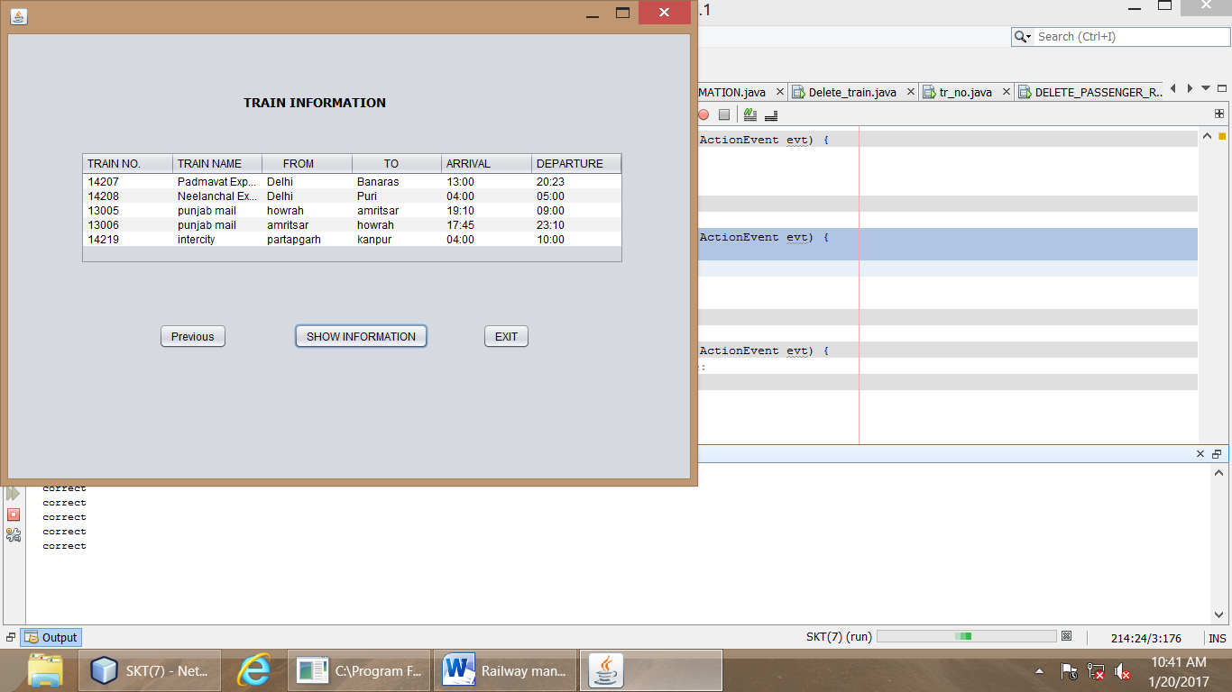

**AFTER CLICKING ON CHECK BY GIVING T_NO. FOLLOWING WINDOW WILL BE DISPLAYED:**

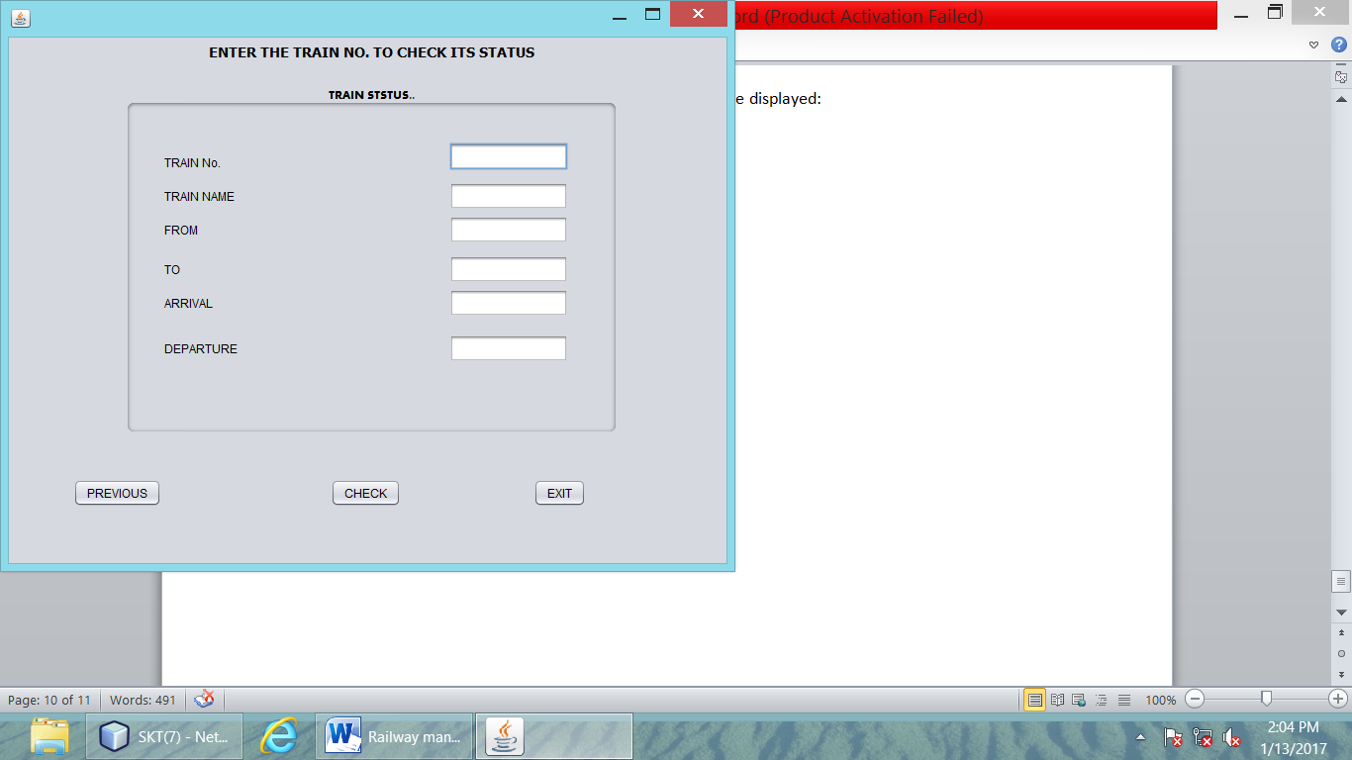

**CODE FOR CHECK BUTTON:**

private void jButton1ActionPerformed(java.awt.event.ActionEvent evt) {

int tn =Integer.parseInt(tr.getText());

String n,f,t,a,d;

try

{

Class.forName("java.sql.Driver");

System.out.println("correct");

Connection co = DriverManager.getConnection("jdbc:mysql://localhost/skt7","root","lps");

System.out.println("correct");

Statement st = co.createStatement();

System.out.println("correct");

String tra = "select * from train where t_no = '"+tn+"';";

System.out.println("correct");

ResultSet rs = st.executeQuery(tra);

System.out.println("correct");

if(rs.next())

{

n= rs.getString(2);

f=rs.getString(3);

t= rs.getString(4);

a=rs.getString(5);

d= rs.getString(6);

nam.setText(n);

fr.setText(f);

too.setText(t);

ar.setText(a);

de.setText(d);

}

}

catch(Exception e)

{

System.out.println("ERROR");

}

**CODE FOR EXIT BUTTON:**

private void jButton2ActionPerformed(java.awt.event.ActionEvent evt) {

System.exit(0);

**CODE FOR PREVIOUS BUTTON:**

private void jButton1ActionPerformed(java.awt.event.ActionEvent evt) {

new POP_UP_MENU().setVisible(true);

this.setVisible(false);

**AFTER CLICKING ON PREVIOUS BUTTON WE WILL JUMP ON POP_UP_MENU WINDOW:**

**OUTPUT FOR CHECK COMMAND:**

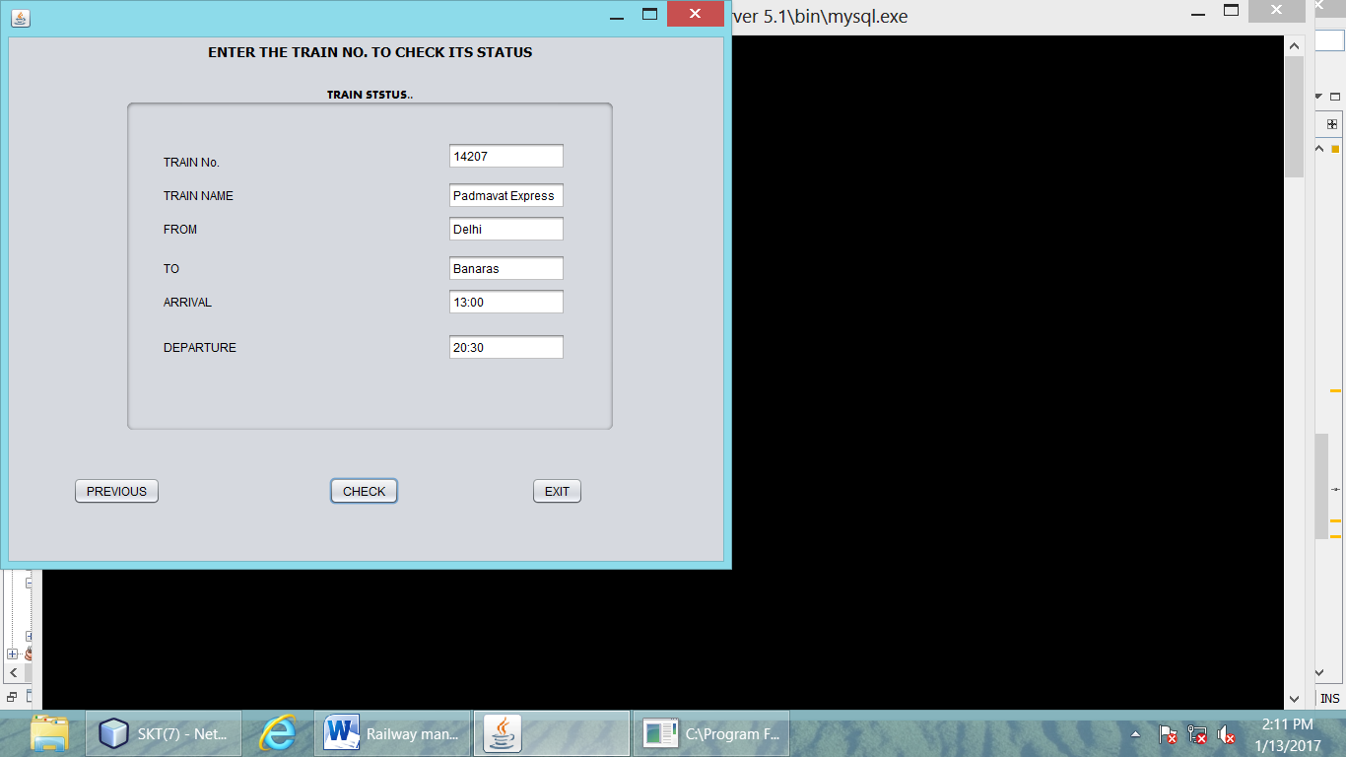

**AFTER CLICKING ON THE PASSANGER INFO FOLLOWING ITEMS WILL BE DISPLAYED:**

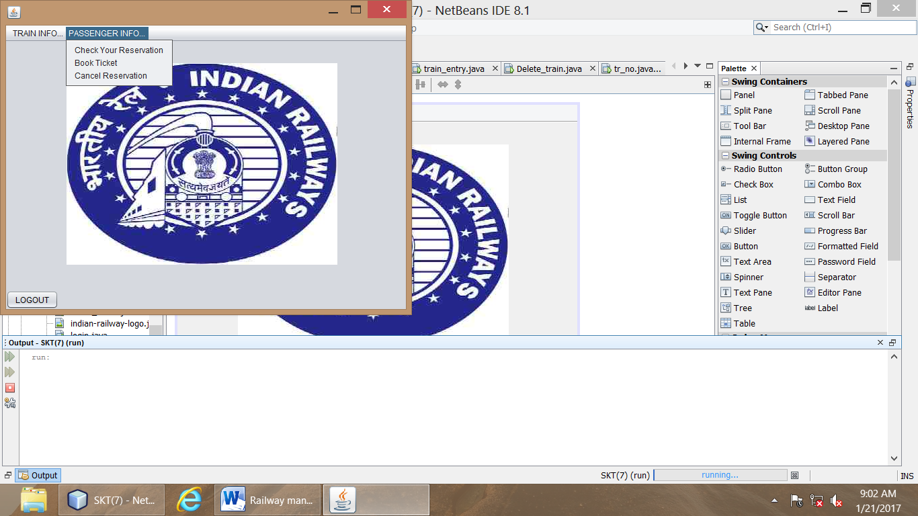

**CODE FOR CHECK YOUR RESERVATION:**

private void jMenuItem7ActionPerformed(java.awt.event.ActionEvent evt) {

new Passenger_Information_Page().setVisible(true);

this.setVisible(false);

**CODE FOR BOOK TICKET:**

private void jMenuItem6ActionPerformed(java.awt.event.ActionEvent evt) {

new ADD_PASSENGER().setVisible(true);

this.setVisible(false);

**CODE FOR CANCEL RESERVATION:**

private void jMenuItem8ActionPerformed(java.awt.event.ActionEvent evt) {

new DELETE_PASSENGER_RECORD().setVisible(true);

this.setVisible(false);

**AFTER CLICKING ON CHECK YOUR RESERVATION FOLLOWING WINDOW WILL BE DISPLAYED:**

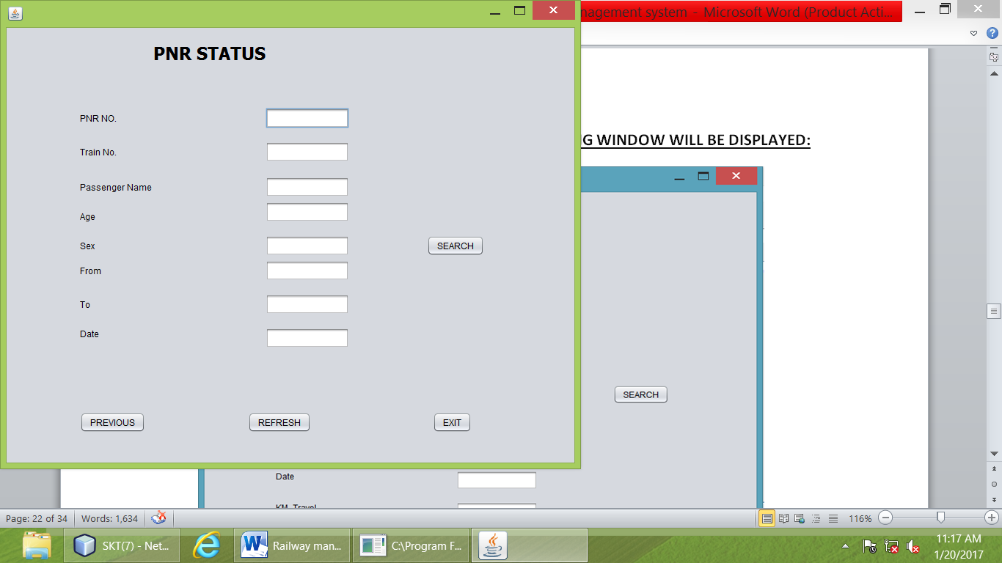

**CODE FOR REFRESH BUTTON:**

private void jButton3ActionPerformed(java.awt.event.ActionEvent evt) {

t1.setText("");

t2.setText("");

t3.setText("");

t4.setText("");

t5.setText("");

t6.setText("");

t7.setText("");

t8.setText("");

t9.setText("");

**CODE FOR EXIT BUTTON:**

private void jButton4ActionPerformed(java.awt.event.ActionEvent evt) {

System.exit(0);

**CODE FOR PREVIOUS BUTTON:**

private void jButton2ActionPerformed(java.awt.event.ActionEvent evt) {

new POP_UP_MENU().setVisible(true);

this.setVisible(false);

**AFTER CLICKING ON PREVIOUS BUTTON WE WILL JUMP ON THE POP_UP_MENU WINDOW:**

**CODE FOR SEARCH BUTTON:**

private void jButton1ActionPerformed(java.awt.event.ActionEvent evt) {

int pnr_no,km_trvl,tr_no,p_age;

String p_nam,p_sex,frm,too,dat;

try

{

Class.forName("java.sql.Driver");

System.out.println("correct");

Connection co = DriverManager.getConnection("jdbc:mysql://localhost/skt7","root","lps");

System.out.println("correct");

Statement st = co.createStatement();

System.out.println("correct");

String pinf = "select * from passenger ;";

System.out.println("correct");

ResultSet rs = st.executeQuery(pinf);

System.out.println("correct");

if(rs.next())

{

pnr_no = rs.getInt(1);

tr_no = rs.getInt(2);

km_trvl = rs.getInt(9);

p_age = rs.getInt(4);

p_nam = rs.getString(3);

p_sex = rs.getString(5);

frm = rs.getString(6);

too = rs.getString(7);

dat = rs.getString(8);

t1.setText(""+pnr_no);

t2.setText(""+tr_no);

t3.setText(""+p_nam);

t4.setText(""+p_age);

t5.setText(""+p_sex);

t6.setText(""+frm);

t7.setText(""+too);

t8.setText(""+dat);

t9.setText(""+km_trvl);

}

}

catch(Exception e)

{

System.out.println("ERROR");}

**OUTPUT FOR SEARCH COMMAND:**

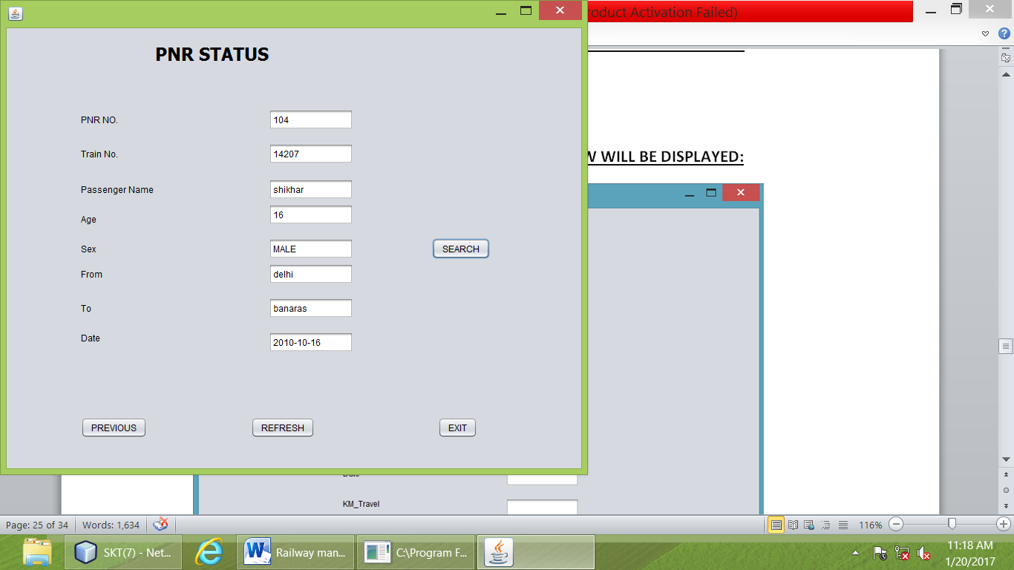

**AFTER CLICKING ON BOOK TICKET FOLLOWING WINDOW WILL BE DISPLAYED:**

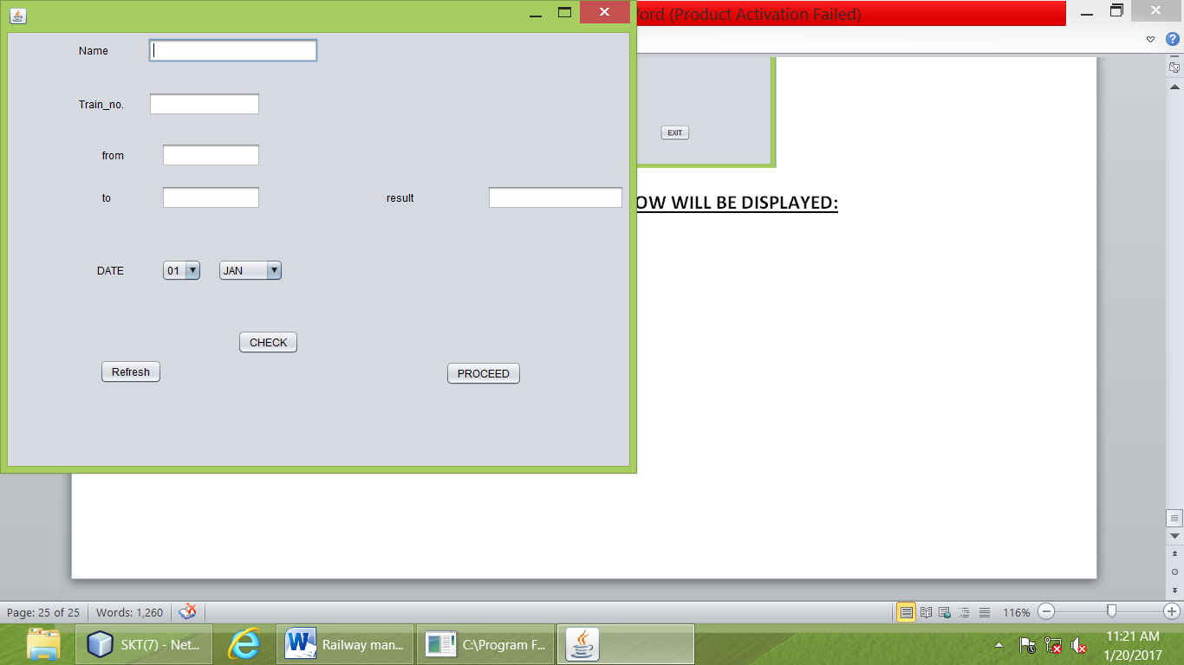

**CODE FOR REFRESH BUTTON:**

private void jButton3ActionPerformed(java.awt.event.ActionEvent evt) {

tf1.setText("");

tf2.setText("");

tf3.setText("");

tf4.setText("");

tf5.setText("");

**CODE FOR CHECK BUTTON:**

private void jButton2ActionPerformed(java.awt.event.ActionEvent evt) {

int tn = Integer.parseInt(tf2.getText());

int da1 = Integer.parseInt((String) date.getSelectedItem());

String mo =(String) mon.getSelectedItem();

if(tn == 14207 && (da1 < 13) && mo.equals("JAN"))

{

tf5.setText("waiting");

}

if((tn == 14207) && (da1>=13 && da1 <=24) && (mo.equals("JAN")))

{

tf5.setText("RAC");

}

if((tn == 14207) && (da1>24 ) && (mo.equals("JAN")))

{

tf5.setText("AVAILABLE");

}

if((tn == 14207) && (mo.equals("JAN")))

{}

else

{if (tn == 14207)

tf5.setText("AVAILABLE");

}

if(tn == 14208 && (da1 < 10) && mo.equals("JAN"))

{

tf5.setText("waiting");

}

if((tn == 14208) && (da1>=10 && da1 <=21) && (mo.equals("JAN")))

{

tf5.setText("RAC");

}

if((tn == 14208) && (da1>21 ) && (mo.equals("JAN")))

{

tf5.setText("AVAILABLE");

}

if((tn == 14208) && (mo.equals("JAN")))

{}

else

{if (tn == 14208)

tf5.setText("AVAILABLE");

}

if(tn == 13005 && (da1 < 11) && mo.equals("JAN"))

{

tf5.setText("waiting");

}

if((tn == 13005) && (da1>=11 && da1 <=27) && (mo.equals("JAN")))

{

tf5.setText("RAC");

}

if((tn == 13005) && (da1>27 ) && (mo.equals("JAN")))

{

tf5.setText("AVAILABLE");

}

if((tn == 13005) && (mo.equals("JAN")))

{}

else

{if (tn == 13005)

tf5.setText("AVAILABLE");

}

if(tn == 13006 && (da1 < 17) && mo.equals("JAN"))

{

tf5.setText("waiting");

}

if((tn == 13006) && (da1>=17 && da1 <=24) && (mo.equals("JAN")))

{

tf5.setText("RAC");

}

if((tn == 13006) && (da1>24 ) && (mo.equals("JAN")))

{

tf5.setText("AVAILABLE");

}

if((tn == 13006) && (mo.equals("JAN")))

{}

else

{if (tn == 13006)

tf5.setText("AVAILABLE");

}

if(tn == 14219 && (da1 < 17) && mo.equals("JAN"))

{

tf5.setText("waiting");

}

if((tn == 14219) && (da1>=17 && da1 <=24) && (mo.equals("JAN")))

{

tf5.setText("RAC");

}

if((tn == 14219) && (da1>24 ) && (mo.equals("JAN")))

{

tf5.setText("AVAILABLE");

}

if((tn == 14219) && (mo.equals("JAN")))

{}

else

{if (tn == 14219)

tf5.setText("AVAILABLE");

}

**CODE FOR PROCEED BUTTON:**

private void jButton1ActionPerformed(java.awt.event.ActionEvent evt) {

ap.tf3.setText(tf1.getText());

ap.tf2.setText(tf2.getText());

ap.tf6.setText(tf3.getText());

ap.tf7.setText(tf4.getText());

if(tf1.getText().equalsIgnoreCase("")||tf2.getText().equalsIgnoreCase("")||tf3.getText().equalsIgnoreCase("")||tf4.getText().equalsIgnoreCase("")||tf5.getText().equalsIgnoreCase(""))

{op1.showMessageDialog(null,"PLEASE INSERT YOUR VALUES FIRST");}

else

{

ap.setVisible(true);

this.setVisible(false);}

**OUTPUT FOR CHECK COMMAND:**

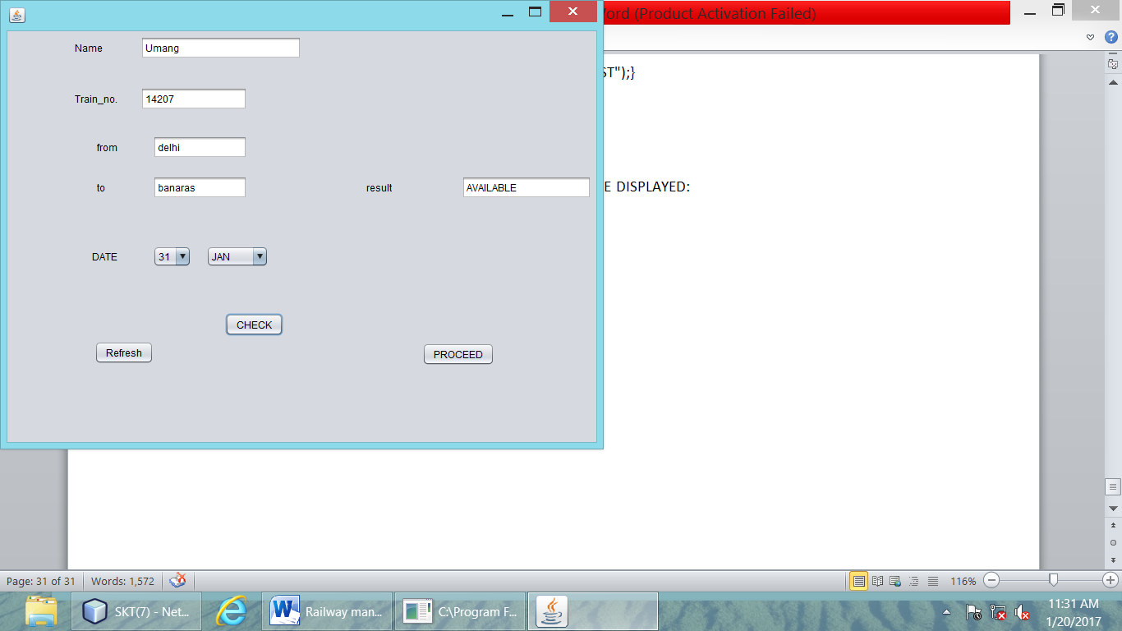

**AFTER CLICKING ON PROCEED BUTTON FOLLOWING WINDOW WILL BE DISPLAYED:**

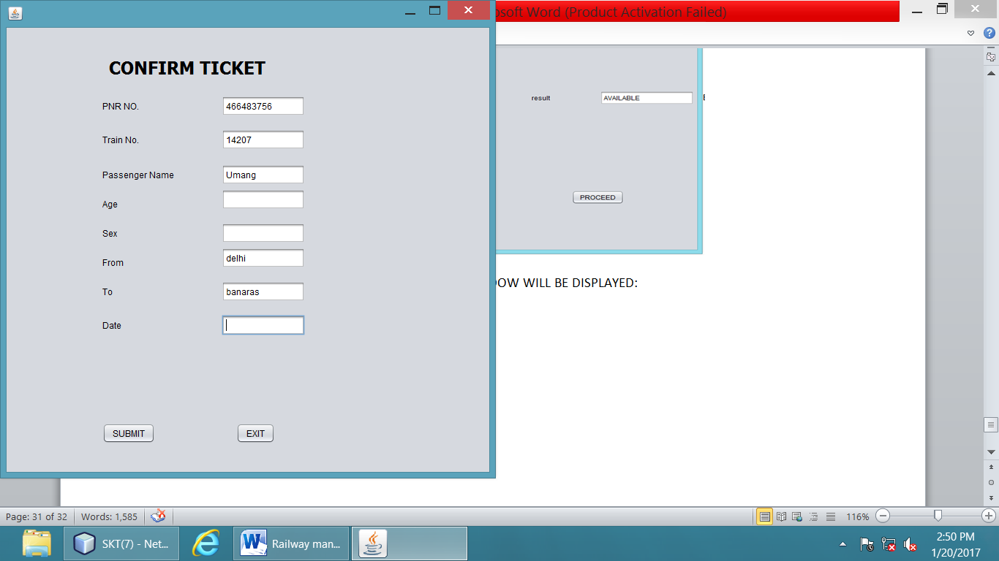

**CODE FOR SUBMIT BUTTON:**

private void jButton2ActionPerformed(java.awt.event.ActionEvent evt) {

int pn, tn,a,km;

String pnam, se, frm, t, dt;

pn = Integer.parseInt(tf1.getText());

tn = Integer.parseInt(tf2.getText());

a = Integer.parseInt(tf4.getText());

pnam = tf3.getText();

se = tf5.getText();

frm = tf6.getText();

t = tf7.getText();

dt = tf8.getText();

int s= op1.showConfirmDialog(null,"Do you Want To Confirm Your Ticket");

if(s==op1.YES_OPTION)

{op1.showMessageDialog(null,"Your Ticket Has Been confirmed");

try

{

Class.forName("java.sql.Driver");

System.out.println("correct");

Connection co = DriverManager.getConnection("jdbc:mysql://localhost/skt7","root","lps");

System.out.println("correct");

Statement st = co.createStatement();

System.out.println("correct");

String ins = "insert into passenger values("+pn+","+tn+",'"+pnam+"',"+a+",'"+se+"','"+frm+"','"+t+"','"+dt+"') ;";

System.out.println("correct");

st.executeUpdate(ins);

System.out.println("correct");

}

catch(Exception e)

{

System.out.println("error");

}

this.setVisible(false);

new POP_UP_MENU().setVisible(true);

}

if(s==op1.NO_OPTION)

{this.setVisible(false);

new POP_UP_MENU().setVisible(true);

}

**CODE FOR EXIT BUTTON:**

private void jButton3ActionPerformed(java.awt.event.ActionEvent evt) {

System.exit(0);

**AFTER CLICKING ON SUBMIT BUTTON FOLLOWING OPTION PANE WILL BE DISPLAYED:**

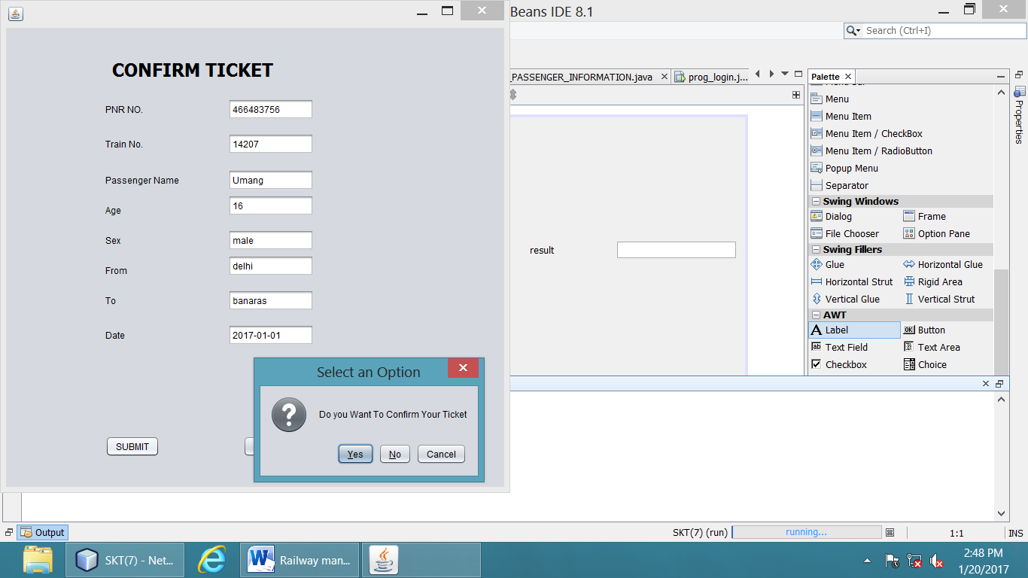

**AFTER CLICKING ON YES BUTTON FOLLOWING OPTION PANE WILL BE DISPLAYED:**

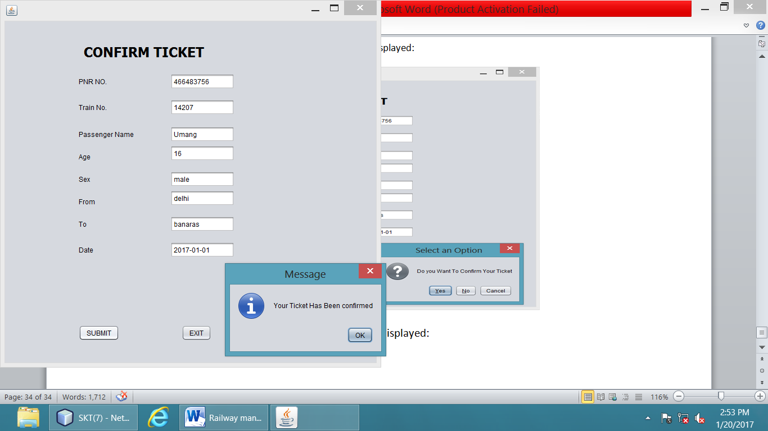

**AFTER CLICKING ON OK BUTTON WE WILL JUMP ON POP_UP_MENU WINDOW:**



**MYSQL TABLES:**

